Task 1:

Find a website that runs on HTTP. Access this website using your device and capture network traces.

http://httpforever.com/

Questions

For the HTTP based website access, answer the following after analysing collected traces of HTTP:

1. What is the name of website?

Name is http://httpforever.com/



1. Find the packet that contains the first GET request for the website you have accessed.



3. Describe all headers and their values in this GET request message.

Host: httpforever.com

Connection: keep-alive

Upgrade-Insecure-Requests: 1

User-Agent: Mozilla/5.0 (Windows NT 10.0; Win64; x64) AppleWebKit/537.36 (KHTML, like Gecko) Chrome/...

Accept: text/html,application/xhtml+xml,application/xml;q=0.9,image/avif,image/webp,\*/\*;q=0.8

Accept-Encoding: gzip, deflate

Accept-Language: en-GB,en-US;q=0.9,en;q=0.8

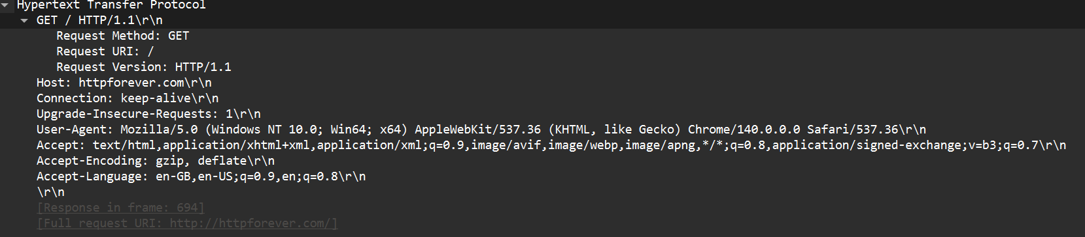

4. Identify the status code in the first server response.

Filter http.response

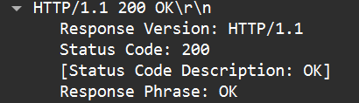

5. How many HTTP response messages are exchanged in total?

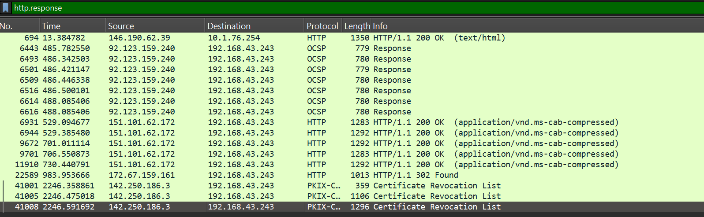

6. Determine whether the connection is persistent or not. Justify with evidence from packet captures.

Filter http.request.method == "GET"

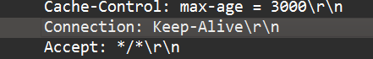

Because of keep alive we can know that the connection is persistent